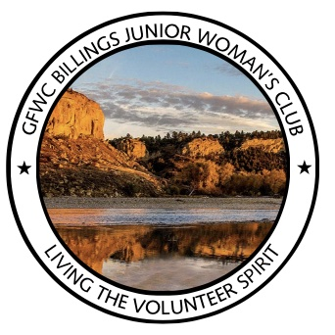
GFWC Billings Junior Woman’s Club
Living the VOLUNTEER Spirit!

P.O. Box 20234 - Billings, MT 59104
gfwcbill@aol.com - gfwcbillings.org

